**CMPE272 TEAM21 FINAL PROJECT**

**LifeLine**

**Activity Diagram:**

**User Login**

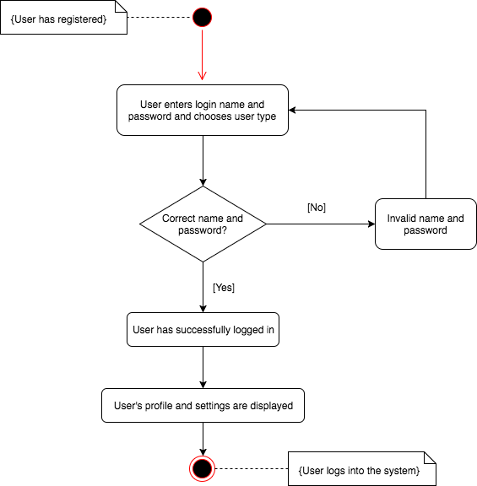

**User Create an Account**

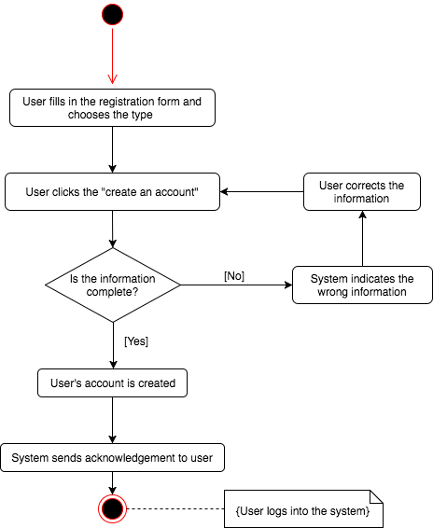

**Donor Register Organ**

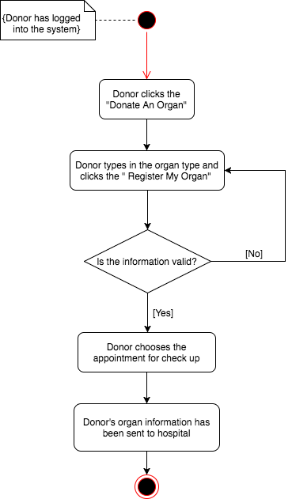

**Hospital Record**

